# BCIT

**Comp 4952 HCI for Application Development**

**Technical Programming Option**

# Option Head Mirela Gutica

**Fall 2022**

Mark: ________ /100

Lab 5 Understanding Controllers and Routing in ASP.NET Core MVC Applications

And Bayesian Theorem

This is an individual assignment. **No late assignments will be accepted**.

**This assignments has 3 parts:**

1. **Part 1:** Read the PP presentation and the documentation content at the links provided in the PP presentation **Module 4 ASP.NET Core MVC Controllers and Routing 2022.** 
   1. Read textbook **Chapter 6: How to work with controllers and routing?**
   2. Include proper routing in your project (no need to submit).
2. **Part 2 (50p):** In your Movie application, do the exercises included in the document: **Understanding Controllers and Routing in ASP.NET Core MVC Applications.** Take screenshots of your output and submit the code.
   1. Answer the question:
      1. What is different in the outcome of this code:

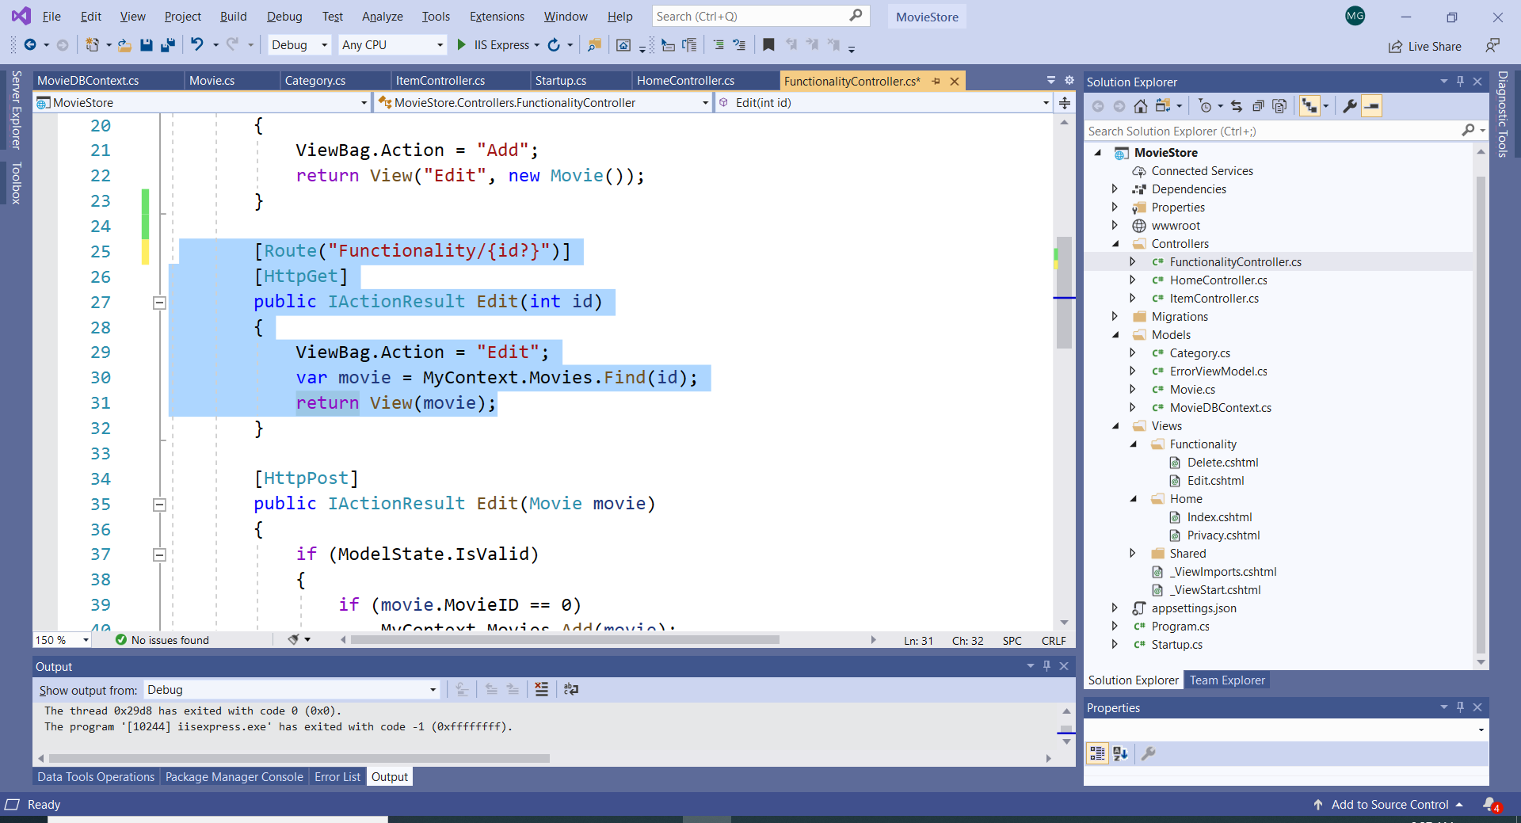

The outcome is a different URL for the functionality route. Through attribute routing, we override the pattern specified in Startup.cs. The route URL for this pattern is now “Functionality/” with an optional id parameter.

1. **Part 3 (50p):** Solve the following problems using (1) the Bayesian Theorem formula and (2) tree diagram representation:
   1. In Vancouver in the month of September there are in average 22 days of rain. When is raining there is a probability of 80% of being windy. However, if it is not raining, there is a probability of 30% of being windy.
2. Calculate the conditional probability (P (“Rain”|”Windy” )that today will rain based on the fact that today is windy.

Average days of rain in September = 22

Days in September = 30

22/30 = 73%

Windy when raining = 80%

Windy when not raining = 30%

Hypothesis: H1=Rain, H2=No Rain

Prior prob of rain = 22/30 = 0.7333

**Answer:**

Prior prob of rain = 22(avg days will rain)/30(days in September) = 0.7333

P(Rain|Windy) = 0.7333*0.8 = 0.5866

1. What are the values of: the likelihood, the prior and the normalized constant?
   1. In a game, players can get o the second level by obtaining an achievement. Three different achievements could each advance a player to the next level. From 10 players,generally 5 would get A1, 3 would get A2 and the rest A3. Consider that if a player gets A1 there is a 50% chance that that player was cheating, for A2 a 30% chance and for A3 a 20% chance. Consider that a player is on the second level and reports that he did not cheat.

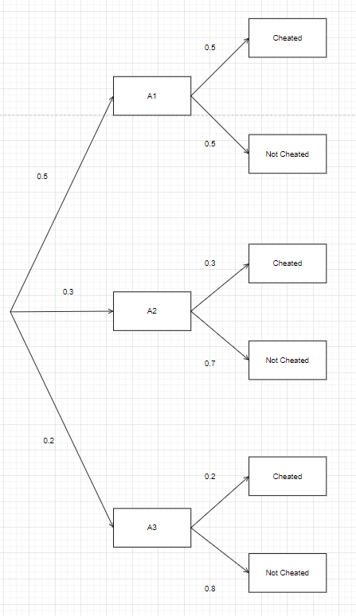

Player achieves A1 = 5/10 = 0.5

Player achieves A2 = 3/10 = 0.333

Player achieves A3 = 2/10 = 0.2

Player A1 cheated = 0.5

Player A2 cheated = 0.3

Player A3 cheated = 0.2

P(A1|Not Cheated)(0.5*0.5) = 0.25

P(A2|Not Cheated) = (0.3*0.7) = 0.21

P(A3|Not Cheated) = (0.2*0.8) = 0.16

P(Not Cheated)

P(0.25 + 0.21 + 0.16) = 0.62

1. What is the probability that the player advanced to this level by receiving A1?

Likelihood = 0.5

Prior = 0.5

Normalized constant = P(0.25 + 0.21 + 0.16) = 0.62

**Answer:**

P(A1|Not Cheated)/ P(Not Cheated)

P(A1|Not Cheated) => (0.5*0.5) = 0.25

= 0.25 / 0.62

Ans = 0.4032

1. What is the probability that the player advanced to this level by receiving A2?

Likelihood = 0.7

Prior = 0.3

Normalized constant = P(0.25 + 0.21 + 0.16) = 0.62

**Answer:**

P(A2|Not Cheated)/ P(Not Cheated)

P(A2|Not Cheated) => (0.3*0.7) = 0.21

= 0.21 / 0.62

Ans = 0.3387

1. What is the probability that the player advanced to this level by receiving A3?

Likelihood = 0.8

Prior = 0.2

Normalized constant = P(0.25 + 0.21 + 0.16) = 0.62

**Answer:**

P(A3|Not Cheated)/ P(Not Cheated)

P(A3|Not Cheated) => (0.2*0.8) = 0.16

= 0.16 / 0.62

Ans = 0.2581